# ACKNOWLEDGEMENT

We would like to express our deepest gratitude to all those who have contributed to the development of our AI desktop voice assistant project.

First and foremost, we extend our sincere appreciation to our project supervisor

Prof. Manu Sood, whose guidance and support were invaluable throughout the entire process. Their expertise and insightful feedback greatly enriched the project and steered us in the right direction.

We are also grateful to Himachal Pradesh University for providing us with the resources and facilities necessary to carry out this project successfully.

Additionally, we would like to acknowledge the contributions of our guide Sanjeev Khan whose expertise and assistance helped us overcome various challenges and refine our approach.

Special thanks to our team members for their dedication, hard work, and collaboration. Each member played a crucial role in the design, development, and testing phases, contributing their unique skills and perspectives.

Last but not least, we extend our appreciation to our families and friends for their unwavering support and understanding during this project.

Thank you all for being part of this journey and for your unwavering commitment to excellence.

# ABSTRACT

In an era where digital technologies are increasingly integrated into daily life, the demand for intuitive and efficient human-computer interaction methods continues to rise. In response to this need, our project introduces an AI desktop voice assistant designed to enhance user productivity and convenience.

This AI desktop voice assistant leverages cutting-edge natural language processing (NLP) and machine learning algorithms to interpret user commands and execute tasks seamlessly. Through continuous learning and adaptation, the assistant becomes increasingly adept at understanding user preferences and providing personalized assistance.

Key features of the AI desktop voice assistant include voice-controlled task execution, realtime information retrieval, calendar management, email integration, and interactive dialogue capabilities. Furthermore, the assistant is equipped with robust security measures to safeguard user data and ensure privacy.

Throughout the development process, emphasis was placed on user experience and accessibility, with intuitive interfaces and customizable settings to accommodate diverse user needs. Extensive testing and refinement were conducted to optimize performance and usability across various computing environments.

In practical applications, the AI desktop voice assistant offers a versatile solution for streamlining daily workflows, managing information overload, and enhancing overall efficiency. By harnessing the power of artificial intelligence, this project aims to redefine the way users interact with desktop computing systems, paving the way for a more intuitive and productive digital experience.

# TABLE OF CONTENTS

|  |  |  |  |  |  |  |  |  |  |  |
| --- | --- | --- | --- | --- | --- | --- | --- | --- | --- | --- |
| 1. | | **Introduction** |  |  |  |  | **07** | |  | |
|  |  | |  |  |  |  |  | | | |
| 2. | | **Technology Stack** |  |  |  |  | **08** | |  | |
|  |  | |  |  |  |  |  | | | |
| 3. | | **Architecture Overview** |  |  |  |  | **09-10** | | |  |
|  |  | |  |  |  |  |  | | | |
| 4. | | **Each Technology’s Contribution** |  |  |  |  | **11** |  | | |
|  |  | |  |  |  |  |  | | | |
| 5. | | **Response Generation** |  |  |  |  | **12** |  | | |
|  |  | |  |  |  |  |  | | | |
| 6. | | **Integration with External Services** |  |  |  |  | **13** |  | | |

|  |  |  |  |  |  |  |  |
| --- | --- | --- | --- | --- | --- | --- | --- |
| 7. | **Error Handling and Recovery** |  |  |  |  | **14** |  |

|  |  |  |  |  |  |  |  |  |  |  |
| --- | --- | --- | --- | --- | --- | --- | --- | --- | --- | --- |
| 8. | | **Testing Methodologies** |  |  |  |  |  |  | **15-16** |  |
|  |  | |  |  |  |  |  |  |  | |
| 9. | | **Future Directions** |  |  |  |  |  |  | **17-18** |  |

|  |  |  |  |  |  |  |  |  |  |  |
| --- | --- | --- | --- | --- | --- | --- | --- | --- | --- | --- |
| 10. | **Conclusion** |  |  |  |  |  |  |  | **19** |  |

|  |  |  |  |  |  |  |  |  |  |  |
| --- | --- | --- | --- | --- | --- | --- | --- | --- | --- | --- |
| 11. |  | **References** |  |  |  |  |  |  |  | **20** |

|  |
| --- |
| **INTRODUCTION** |
| In today's fast-paced world, technology has become an integral part of our daily lives. With |
| the rise of artificial intelligence (AI), voice assistants have gained immense popularity for their convenience and efficiency in performing various tasks. Our project aims to develop a |
| sophisticated AI desktop voice assistant that can assist users in accomplishing tasks using |
| natural language voice commands. |
| **Overview of the AI Voice Assistant Project:**  The AI voice assistant project is designed to create a virtual assistant that can understand and |
| respond to user commands spoken in natural language. The primary purpose of this project is |
| to enhance user productivity and convenience by providing hands-free interaction with their desktop computers. |
| **Key Goals of the Project:** |

1. Natural Language Understanding: The voice assistant should be able to accurately interpret and understand user commands spoken in natural language, allowing for seamless interaction.
2. Task Automation: The assistant should be capable of automating various tasks such as fetching information from the web, opening applications, setting reminders, and providing helpful responses to user queries.
3. Personalization: The assistant should be customizable to cater to the individual preferences and needs of users. It should learn from user interactions and adapt its responses accordingly.
4. Reliability and Efficiency: The assistant should be reliable, responsive, and efficient in executing tasks to enhance user experience and productivity.
5. Continuous Improvement: The project should allow for ongoing development and improvement of the voice assistant's capabilities through feedback and iteration.

|  |
| --- |
|  |
| By achieving these goals, our AI desktop voice assistant aims to revolutionize the way users interact with their computers, making everyday tasks more accessible and efficient through voice commands. |

# TECHNOLOGY STACK

|  |
| --- |
| The provided code for the AI desktop voice assistant utilizes a combination of technologies to |
| achieve its functionality. Primarily, it leverages Python for its ease of use and extensive |
| libraries. The code utilizes the **pyttsx3** library for text-to-speech conversion, allowing the |
| assistant to communicate audibly with the user. For speech recognition, it employs the **speech_recognition** library, enabling the assistant to understand spoken commands through the microphone. Additionally, the **datetime** module is used to fetch the current time, enabling the assistant to greet the user appropriately based on the time of day.    To enhance its capabilities, the assistant interacts with external resources. It utilizes the |
| **wikipedia** library to fetch information from Wikipedia based on user queries, providing |
| responses to user inquiries. The **webbrowser** module enables the assistant to open web pages such as YouTube, Google, and Stack Overflow in the default web browser, expanding its functionality beyond local operations. Furthermore, the **os** module allows the assistant to |
| interact with the operating system, enabling it to open applications like Visual Studio Code. |
|  |
| Overall, this technology stack empowers the AI desktop voice assistant to provide a seamless |
| user experience by enabling speech recognition, text-to-speech conversion, interaction with external resources, and system-level operations, all within a Python environment. By leveraging these technologies, the assistant can understand user commands, retrieve information, perform tasks, and interact with users in a natural and intuitive manner, |
| enhancing productivity and convenience in desktop computing environments. |

**ARCHITECTURE OVERVIEW**

Architecture diagram

**+------------------------------------------------------+ | User Interaction Layer |**

**+------------------------------------------------------+**

**|**

**V**

**+------------------------------------------------------+**

**| Speech Recognition |**

**| (speech_recognition) |**

**+------------------------------------------------------+**

**|**

**V**

**+------------------------------------------------------+**

**| Text-to-Speech Conversion |**

**| (pyttsx3) |**

**+------------------------------------------------------+**

**|**

**V**

**+------------------------------------------------------+**

**| Task Execution |**

**| (wikipedia, webbrowser, os) |**

**+------------------------------------------------------+**

**Explanation of Each Component:**

1. **User Interaction Layer**:
   * This is the interface through which the user interacts with the voice assistant. It typically involves speaking voice commands.

1. **Speech Recognition (speech_recognition)**:
   * This component listens to the user's voice commands using the microphone and converts them into text. It utilizes the **speech_recognition** library in Python.

1. **Text-to-Speech Conversion (pyttsx3)**:
   * Once the user's command is recognized, this component converts the text responses into audible speech. It uses the **pyttsx3** library for text-to-speech conversion.

1. **Task Execution**:
   * This component executes the tasks requested by the user based on the recognized commands. It includes functionalities such as fetching information from Wikipedia (**wikipedia**), opening web pages (**webbrowser**), interacting with the operating system (**os**), and providing responses to user queries.

**Role of Each Component:**

* + **Speech Recognition**: It enables the assistant to understand user commands spoken in natural language, facilitating hands-free interaction.

* + **Text-to-Speech Conversion**: This component allows the assistant to communicate audibly with the user, providing responses to their queries in a human-like voice.

* + **Task Execution**: It performs various tasks based on the user's commands, such as fetching information from Wikipedia, opening web pages, telling the time, opening applications, and exiting the assistant.

## EACH TECHNOLOGY’s CONTRIBUTION

|  |
| --- |
|  |

1. **Text-to-Speech Conversion (Pyttsx3)**:
   * Pyttsx3 is used for text-to-speech conversion, enabling the assistant to speak responses to the user.
   * This technology allows the assistant to provide audible feedback to the user, making the interaction more natural and intuitive.

1. **Speech Recognition (SpeechRecognition)**: • SpeechRecognition is utilized for converting spoken words into text.
   * With speech recognition, the assistant can understand user commands spoken in natural language, enabling hands-free interaction.

1. **Datetime Module**:
   * The Datetime module is used to work with dates and times.
   * It enables the assistant to greet the user appropriately based on the current time, enhancing the user experience.

1. **Wikipedia Module**:
   * The Wikipedia module provides access to the Wikipedia API for fetching information.
   * By using the Wikipedia module, the assistant can search and retrieve information from Wikipedia based on user queries, expanding its knowledge base.

1. **Webbrowser Module**:
   * The Webbrowser module provides functionality to interact with web browsers.
   * It allows the assistant to open web pages such as YouTube, Google, and Stack Overflow in the default web browser, providing quick access to online resources.

1. **OS Module**:
   * The OS module provides a way to interact with the operating system.
   * It enables the assistant to open applications like Visual Studio Code, enhancing its utility by allowing it to perform system-level tasks.

1. **SAPI5 (Microsoft Speech API)**: • SAPI5 is a speech API developed by Microsoft for speech synthesis.
   * By using SAPI5, the assistant can interact with the voice synthesis capabilities of the Windows operating system, enabling it to speak with a natural-sounding voice.

## RESPONSE GENERATION

|  |  |
| --- | --- |
| **Overview of How the System Generates Responses to User Queries:** |  |
|  |
|  | |

1. **Speech Recognition**:
   * The system begins by listening to the user's voice commands using the microphone and converts them into text using speech recognition technology.

1. **Query Processing**:
   * Once the user's command is recognized, the system processes the query to understand the user's intent and determine the appropriate response.

1. **Response Generation**:
   * Based on the processed query, the system generates a response to provide relevant information or perform a requested action.

|  |  |  |  |  |  |  |  |
| --- | --- | --- | --- | --- | --- | --- | --- |
| **Discussion of Response Generation Techniques:** | | | | | | |  |
|  | | | | | | |
|  | | | | | | | |
| 1. | | **Template-Based Responses** | | | | : | | | |
|  | | | • Template-based responses involve predefined message templates that are selected and | | | | | | |
| filled with appropriate content based on the user's query. These templates cover | | | | | | |
| common scenarios or tasks that the assistant can handle. | | | | | | |
| • In the provided code, template-based responses are used for greeting the user based on the time of day (e.g., "Good morning Baabaii!") and providing feedback during the interaction (e.g., "Boool brooo I am listening..."). | | | | | | |
|  | | | | | | |
| 2. | | **Rule-Based Responses** | | | : | | | | |
|  | | | • Rule-based responses rely on a set of predefined rules or conditions to determine the | | | | | | |
| appropriate response to a user query. These rules are typically based on if-else statements or conditional logic.  • In the code, rule-based responses are used to handle specific user commands, such as opening web pages (e.g., YouTube, Google) or applications (e.g., Visual Studio Code). Each command triggers a specific action based on predefined rules. | | | | | | |
|  |  | | | | | |
| 3. | | **Machine Learning-Based Responses** | | | | | : | | |
|  | | | • While not explicitly implemented in the provided code, machine learning-based | | | | | | |
| responses involve training models on large datasets of user queries and corresponding responses. These models learn patterns in the data and generate responses based on learned patterns.  • Machine learning techniques could be applied to improve the assistant's understanding of user queries, enabling it to provide more accurate and contextually relevant responses over time. | | | | | | |
|  | | |  | | | | | | |

|  |  |  |  |  |  |  |  |  |  |  |  |  |
| --- | --- | --- | --- | --- | --- | --- | --- | --- | --- | --- | --- | --- |
|  | | **INTERACTION WITH EXTERNAL SERVICES** | | | | | | | | | |  |
|  | | | | | | | | | |
| **Explanation of Integration with External APIs or Services:** | | | | | | | | | | | | |  | | |
|  | | | | | | | | | | | | |
|  | | | | | | | | | | | | | | | |
| 1. | | | | **Wikipedia Integration** | | | | | | | | : | | | | | | |
|  | | | | | | • The voice assistant integrates with Wikipedia's API to fetch information in response | | | | | | | | | | | | |
| to user queries related to general knowledge or topics of interest. | | | | | | | | | | | | |
| • When the user asks for information from Wikipedia, the assistant sends a request to | | | | | | | | | | | | |
| Wikipedia's API, retrieves the relevant information, and presents it to the user through text-to-speech conversion. | | | | | | | | | | | | |
| 2. | | | | **Web Browser Integration** | | | | | | | | | : | | | | | |
|  | | | | | | • The assistant can open web pages in a web browser by integrating with the | | | | | | | | | | | | |
| webbrowser module, which provides a simple interface to open URLs.  • When the user requests to open a specific website (e.g., YouTube, Google, Stack Overflow), the assistant sends a request to the respective website's URL, and the web browser opens the page accordingly. | | | | | | | | | | | | |
| 3. | | | | **Operating System Interaction** | | | | | | | | | | : | | | | |
|  | | | | | | • The assistant interacts with the operating system using the os module to perform | | | | | | | | | | | | |
| actions such as opening applications.  • For example, when the user requests to open Visual Studio Code, the assistant sends a | | | | | | | | | | | | |
| command to the operating system to start the application using the specified file path. | | | | | | | | | | | | |
|  | | | | | | | | | | | | | | | | |
| **Examples of Common Integrations:** | | | | | | | | | | | | | | | | |
| 1. | | | **Weather APIs** | | | | | | | : | | | | | | | | |
|  | | | | | | • The voice assistant can integrate with weather APIs to provide users with real-time | | | | | | | | | | | | |
| weather updates based on their location or specified location.  • Users can ask questions like "What's the weather like today?" or "What's the forecast for tomorrow?" and the assistant can fetch the weather information from the API and provide the response. | | | | | | | | | | | | |
| 2. | | | **Calendar Services** | | | | | | | | : | | | | | | | |
|  | | | | | | • Integration with calendar services allows users to manage their schedules, set | | | | | | | | | | | | |
| reminders, and access their calendar events through voice commands.  • Users can ask questions like "What's on my schedule for today?" or "Remind me to call John at 3 PM tomorrow," and the assistant can interact with the calendar service API to perform the requested actions. | | | | | | | | | | | | |
| 3. | | | **News APIs** | | | | | : | | | | | | | | | | |
|  | | | | | | • The voice assistant can integrate with news APIs to provide users with the latest news | | | | | | | | | | | | |
| updates and headlines.  • Users can ask questions like "What's the latest news?" or "Tell me about the top headlines," and the assistant can fetch the news articles from the API and read them aloud to the user. | | | | | | | | | | | | |
|  | | |  | | | | | | | | | | | | | | | |
|  | | | | | | | | **ERROR HANDLING AND RECOVERY** | | | | | | |  | |
|  | | | | | | |
|  | | | | | | | | | | | | | | | | |

1. **Error Handling in Speech Recognition:**
   * The **takeCommand()** function uses the SpeechRecognition library to capture user input through the microphone. In case there's an error during speech recognition, such as failure to recognize speech or connection issues, the code catches the exception using a try-except block. If an exception occurs, the assistant notifies the user to repeat their command by saying "Baavee... Say that again" and continues listening for input.
2. **Error Handling in Wikipedia Search:**
   * When the user requests information from Wikipedia, the code attempts to fetch a summary of the relevant topic using the **wikipedia.summary()** function. If there's an error, such as a disambiguation error (multiple possible matches for the query), the code catches the **wikipedia.exceptions.DisambiguationError** exception. In response, the assistant informs the user to be more specific in their query by saying "Can you please be more specific?".
3. **Error Handling in Web Browsing:**
   * The assistant can open web pages using the **webbrowser.open()** function based on user commands like "open YouTube" or "open Google". If there's an error while opening the specified URL, such as network issues or invalid URLs, the **webbrowser.open()** function may raise exceptions. However, the code doesn't explicitly handle these exceptions. Instead, the browser itself might display an error message to the user.
4. **Error Handling in Operating System Interaction:**
   * When the user commands to open specific applications like Visual Studio Code using the **os.startfile()** function, the code attempts to start the application by executing the provided file path. If there's an error, such as an invalid file path or missing file, the **os.startfile()** function may raise exceptions. However, similar to web browsing errors, the code doesn't handle these exceptions explicitly.

|  |  |  |  |  |
| --- | --- | --- | --- | --- |
|  | | | | |
| **Strategies for Gracefully Handling Errors:** | | | | |
| • | **Informative Feedback:** | The voice assistant provides informative feedback to the user | |
|  | when an error occurs, guiding them on how to proceed. For instance, it asks the user to repeat their command if speech recognition fails or requests the user to be more specific if there's ambiguity in the query. | | |
|  |  | | |
| • | **User-Friendly Responses:** | | The error messages conveyed by the voice assistant are |
|  | user-friendly and designed to maintain a conversational tone, ensuring a positive user experience even in error scenarios. | | |

|  |  |  |  |  |
| --- | --- | --- | --- | --- |
| • | **Continuous Listening:** | | After encountering an error, the voice assistant resumes | |
|  | listening for user input, allowing the user to provide a new command without needing to restart the application. | | | |
|  | | | **TESTING METHODOLOGIES** | |  |

1. **Unit Testing:**
   * Unit testing involves testing individual components or modules of the voice assistant in isolation. For this project, unit tests can be written to validate the functionality of functions such as **speak()**, **wishMe()**, and **takeCommand()**. Mock objects or stubs may be used to simulate dependencies.
2. **Integration Testing:**
   * Integration testing verifies that the different components of the voice assistant work together as expected. This includes testing interactions between modules such as speech recognition, text-to-speech conversion, and external API calls. Integration tests ensure seamless communication between these components.
3. **Functional Testing:**
   * Functional testing evaluates the voice assistant's ability to perform specific functions as intended. Test cases are designed to validate features such as fetching information from Wikipedia, opening web pages, retrieving the current time, and executing system commands. Functional testing ensures that the voice assistant meets the functional requirements defined for the project.
4. **End-to-End Testing:**
   * End-to-end testing assesses the entire user interaction flow, from issuing voice commands to receiving appropriate responses. This type of testing evaluates the voice assistant's behavior in real-world scenarios, including handling multiple commands consecutively and responding accurately to various user inputs.

|  |  |
| --- | --- |
| **Overview of Testing Tools and Frameworks:** |  |
|  |
|  | |

1. **Pytest:**
   * Pytest is a popular testing framework for Python that can be used for unit testing, integration testing, and functional testing. It provides a simple syntax for writing test cases and supports fixtures for setting up test environments.
2. **Mock Library:**
   * The **unittest.mock** module in Python's standard library can be used to create mock objects for testing. Mocking external dependencies such as speech recognition APIs and web browsers allows for controlled testing environments.
3. **Coverage.py:**
   * Coverage.py is a tool for measuring code coverage during testing. It helps identify areas of code that have not been exercised by tests, ensuring comprehensive test coverage.
4. **SpeechRecognition Library:**
   * The SpeechRecognition library itself can be used to verify the accuracy and reliability of speech recognition. Test cases can be designed to evaluate the recognition accuracy for various accents, languages, and environmental conditions.
5. **Manual Testing:**
   * Manual testing is also essential for validating the voice assistant's behavior in realworld scenarios. Testers can interact with the assistant using voice commands and evaluate its responses for correctness, clarity, and naturalness.

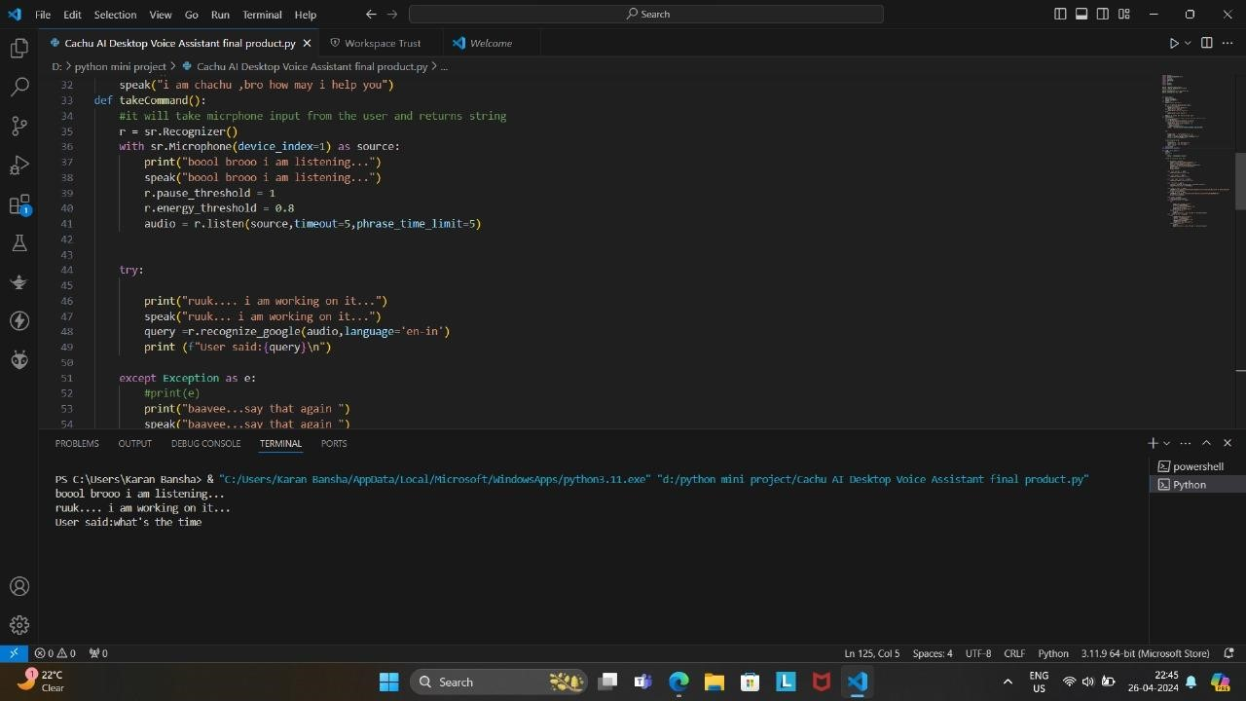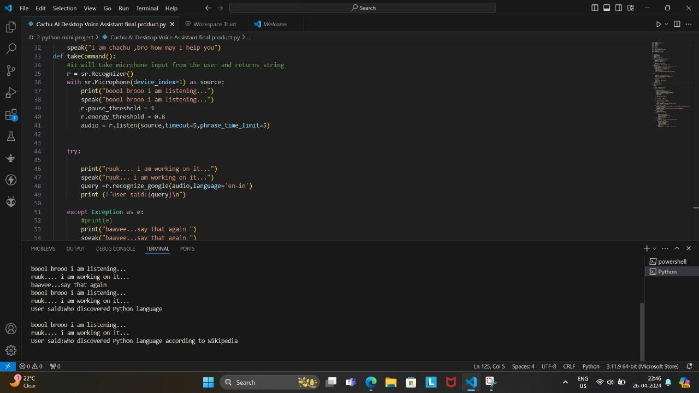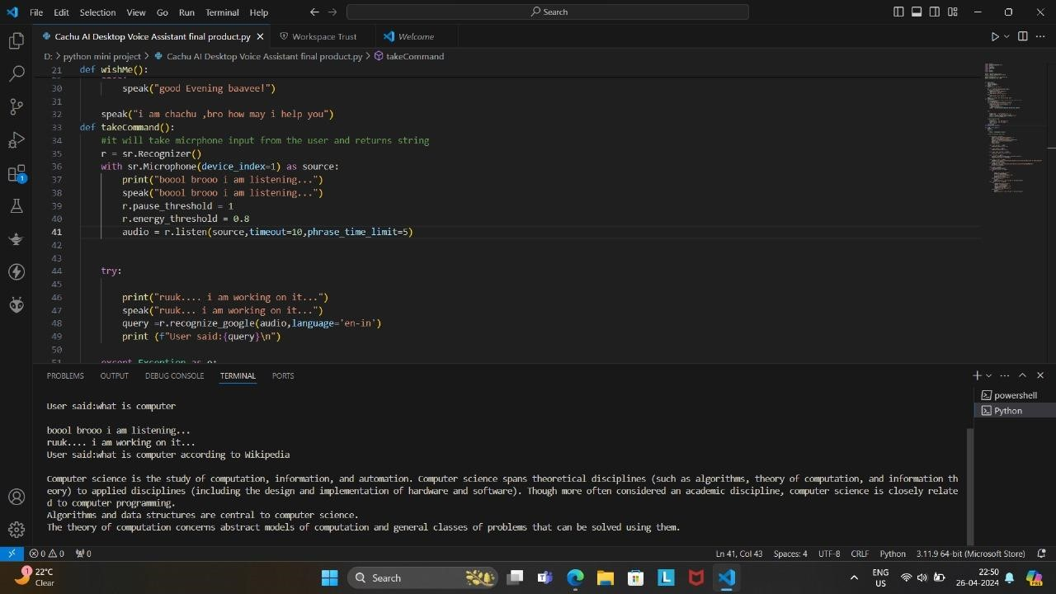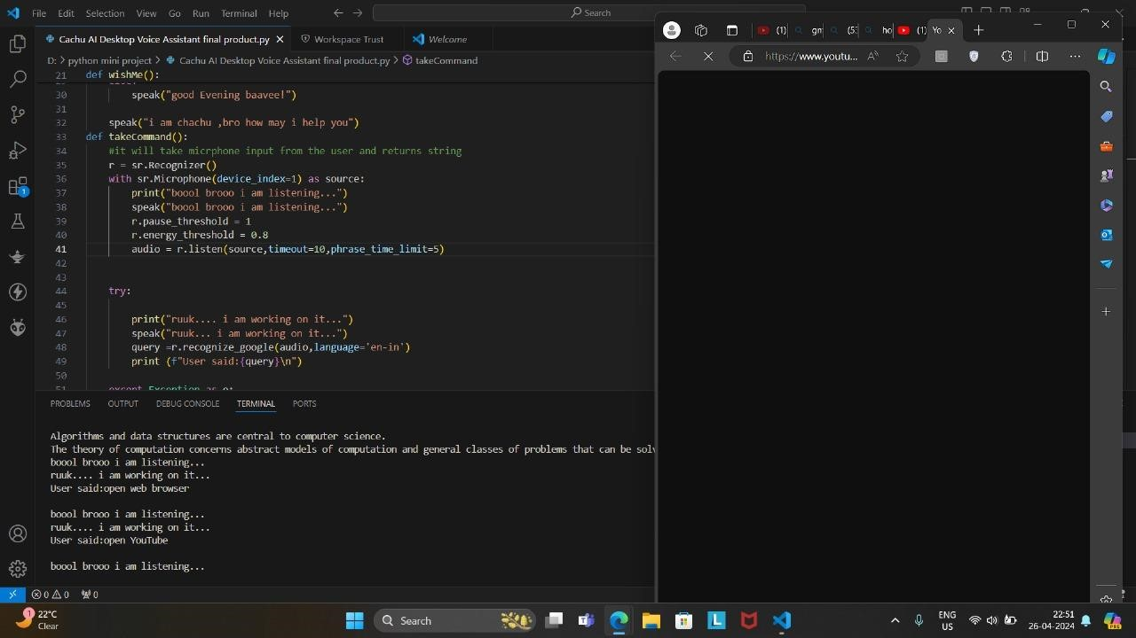

|  |  |
| --- | --- |
|  | |
|  |  |
|  |  |

### POTENTIAL FUTURE ENHANCEMENTS AND DEVELOPMENT

1. **Natural Language Understanding (NLU):**
   * Integrating advanced natural language understanding techniques could enhance the voice assistant's ability to comprehend and respond to user queries more accurately. This involves leveraging machine learning models such as BERT or GPT to interpret the user's intent and extract relevant information from the queries.

1. **Personalization:** • Implementing personalization features would allow the voice assistant to adapt its responses based on the user's preferences, historical interactions, and context. This could include features like learning user preferences for news topics, preferred search engines, or frequently visited websites.

1. **Multi-Language Support:**
   * Adding support for multiple languages would broaden the voice assistant's accessibility and user base. This involves training language-specific models for speech recognition, text-to-speech conversion, and natural language processing to understand and respond to queries in different languages.

1. **Contextual Understanding:** • Enhancing the voice assistant's ability to maintain context across multiple interactions would result in more meaningful and coherent conversations. Implementing contextaware dialogue management techniques would enable the assistant to remember previous interactions and provide relevant responses accordingly.

1. **Emotion Recognition:**
   * Integrating emotion recognition capabilities could enable the voice assistant to detect the user's emotional state based on speech patterns and respond empathetically. This could lead to more personalized and human-like interactions, enhancing user satisfaction and engagement.

|  |  |  |  |  |  |  |  |  |
| --- | --- | --- | --- | --- | --- | --- | --- | --- |
|  | | | | | | | | |
| **EXPLORATION OF EMERGING TECHNOLOGIES AND TRENDS** | | | | | | | | |
| 1. | | **Conversational AI and Chatbots:** | | | | |  | | | |
|  | | | • The integration of conversational AI and chatbot technologies continues to evolve, allowing voice assistants to engage in more natural and contextually relevant | | | | | | | |
| conversations. Techniques such as reinforcement learning and transfer learning are being explored to improve conversational agents' capabilities. | | | | | | | |
|  |  | | | | | | |
| 2. | | **Voice Cloning and Synthesis:** | | | |  | | | | |
|  | | | • Advancements in voice cloning and synthesis technologies enable the creation of | | | | | | | |
| highly realistic and customizable voices for voice assistants. These technologies leverage deep learning models to generate synthetic speech that closely mimics human speech patterns, enhancing the voice assistant's naturalness and | | | | | | | |
| expressiveness. | | | | | | | |
|  | | | | | | | |
| 3. | | **Privacy and Security:** | | |  | | | | | |
|  | | | • With growing concerns about data privacy and security, future voice assistants are | | | | | | | |
| expected to prioritize privacy-preserving techniques such as federated learning, | | | | | | | |
| differential privacy, and on-device processing. These approaches aim to protect user | | | | | | | |
| data while still delivering personalized and contextually relevant experiences. | | | | | | | |
|  | |  | | | | | | | | |
| 4. | | **Edge Computing and On-Device Processing:** | | | | | |  | | |
|  | | | • Edge computing and on-device processing empower voice assistants to perform | | | | | | | |
| computation locally on the user's device, reducing latency and dependency on cloud | | | | | | | |
| services. This trend enables faster response times, offline functionality, and improved | | | | | | | |
| privacy by minimizing data transmission to remote servers. | | | | | | | |
|  | |  | | | | | | | | |
|  | | | | | | | | |
| 5. | | **Augmented Reality (AR) and Wearable Devices:** | | | | | | |  | |
|  | | | • The integration of voice assistants with augmented reality (AR) and wearable devices | | | | | | | |
| presents new opportunities for hands-free interaction and immersive experiences. Voice commands can be used to control AR applications, access information, and perform tasks in a hands-free manner, enhancing user convenience and accessibility. | | | | | | | |

### CONCLUSION

|  |  |  |
| --- | --- | --- |
| In conclusion, the provided code lays the foundation for a simple yet functional voice  assistant implemented in Python. It utilizes various libraries such as **pyttsx3** for text-to- | | |
| speech conversion, **speech_recognition** for speech recognition, and  information from Wikipedia, among others. The assistant greets the user based on the time of day, listens for user commands through speech input, and performs basic tasks such as searching Wikipedia, opening websites, retrieving the current ti | **wikipedia** | for retrieving |
| me, and launching |
| applications. | | |
|  | | |
| While the current implementation serves as a starting point, there are several areas for | | |
| improvement and expansion. For instance, enhancing the assistant's natural language understanding capabilities could enable it to better interpret user queries and provide more accurate responses. Integrating personalization features would allow the assistant to tailor its | | |
| responses based on individual user preferences and historical interactions, leading to a more | | |
| personalized user experience. | | |
|  | | |
| Furthermore, exploring emerging technologies and trends such as conversational AI, voice cloning, and augmented reality presents opportunities to enhance the assistant's functionality | | |
| and user engagement. By leveraging advancements in these areas, the voice assistant could | | |
| evolve into a more intelligent and versatile AI companion capable of addressing a wider | | |
| range of user needs and preferences. | | |
| In summary, while the current implementation provides a basic demonstration of a voice assistant, there is significant potential for future enhancements and developments to further improve its capabilities and user experience. With continued innovation and exploration of emerging technologies, the voice assistant could become an indispensable tool for users seeking assistance with various tasks and inquiries in a hands-free and intuitive manner. | | |

# REFERENCES

* Code Tutorials – YOUTUBE

* Geeks & Geeks – GOOGLE

* Stack Overflow

* Fundamentals of Python – TEXT BOOK

|  |  |  |  |  |
| --- | --- | --- | --- | --- |
| • | Pyttsx3 | : Documentation: | <https://pyttsx3.readthedocs.io/en/latest/> |  |

* SpeechRecognition: Documentation: <https://pypi.org/project/SpeechRecognition/>

* Wikipedia API: Documentation: <https://pypi.org/project/wikipedia-api/>

* Webbrowser:Python Standard Library Documentation: <https://docs.python.org/3/library/webbrowser.html>

* Datetime:Python Standard Library Documentation: <https://docs.python.org/3/library/datetime.html>

* OS (Operating System Interface): Python Standard Library Documentation: <https://docs.python.org/3/library/os.html>

* Google Speech Recognition API: Documentation: <https://pypi.org/project/SpeechRecognition/>

* Microsoft SAPI5: Documentation: [https://docs.microsoft.com/enus/windows/win32/sapi/sapi-5-1](https://docs.microsoft.com/en-us/windows/win32/sapi/sapi-5-1)

|  |  |  |
| --- | --- | --- |
| • | Artificial Intelligence: A Modern Approach – TEXT BOOK |  |